Ruby Daniels
Consultant herbalist and Forest Farmer
Lanark, WV

Herbalist Ruby Daniels is an Afrilachian forest farmer, living on her family homeplace in the former African American coal town of Stanaford, WV. As a girl growing up in Maryland, Ruby spent summers in Stanaford with her grandmother, who was known for her herbal knowledge and healing abilities. From conversations with her grandmother and other mothers of the community, and through her studies of the WPA slave narratives, Ruby came to recognize and apply distinctly African ways of interacting with Appalachian herbs and roots, among which ginseng was no more significant than a number of spiritually and physically potent rhizomes known among African Americans in the region. Ruby conserves ginseng by working with landowners to identify places to grow it for seeds and the harvest of aerial parts, while using alternatives to American ginseng in treating patrons of the business she founded and named after her great grandmother: Creasy Jane’s Herbal Remedies.

“Now, for me, ginseng is, like, I do not use it, I do not offer it to anybody. Because it is endangered. It has a high demand all over the world, especially in China. And people come here to West Virginia, North Carolina, to the Appalachian Mountains, and they dig it. And then it takes 10 years for this plant to grow. . . just to even to be usable. But imagine if it was a plant, it's been sitting for 40-60 years. Could you imagine the amount of medicine in that?”

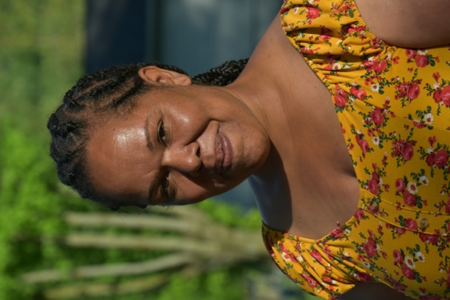
Ruby Daniels. Photo by Mary Hufford

As an Afrolachian Forest Farmer, Ruby Daniels is foregrounding African American history in a region where it has long been invisible. Her family presence in Stanaford, WV dates back to when her great-great grandfather, a freed slave named William Crite, came there to work in the coal mines. Homesteading there for many decades, Crite and his descendants combined the wages of the mines with the fruits of the family’s 70 acres of forest, field, and streams. Ruby’s parents were among those who left the coalfields in the mid-20th century Appalachian diaspora. As a child growing up in Columbia, Maryland, Ruby eagerly looked forward to summers in Stanaford, under the care of her grandmother, Fannie Shepherd, known in the community as a healer. “I was priviledged to have a grandmother who was born in 1917,” Ruby recalled, “And live till she was 100 years old. She saw the world change. She was very verbal, and she loved to talk about old stories. . . Talking to my grandma about herbs, like ‘What’d you use?’ And her answers were always so cool. It was amazing.”
After earning a Master of Science degree in Herbal Therapeutics from Maryland University of Integrative Health, Ruby returned to Stanaford and started a company named Creasy Jane’s, after her great-grandmother. From the beginning, that work has included recovering a place for African American herbal knowledge in narratives of Central Appalachia. “The Afrilachian piece has been hidden for so long. . . .When I was in herbal school I was taught that African Americans knew nothing of the herbs here, and the only way we learned about them was from Native Americans and Caucasians.” Determined to address the silence on African medicinal and herbal knowledge in Appalachian history, Ruby studied the WPA slave narratives. There she discovered parallels between what was recorded and what she remembered and observed among older African American women in the coal camps, parallels with distinctively African antecedents, such as the recognition and treatment of spiritual dimensions of illness and healing, a process in which the ancestors play a crucial role. Recalling that under Virginia law, slaves were forbidden to practice herbal medicine, Ruby emphasized, “It was punishable by death if you were caught using herbs….So because of slavery, that got interrupted. But we still did it. We just hid it.”
The Appalachian mountains harbor many roots and herbs known to Ruby’s grandmother’s generation. While ginseng might be dug for cash, there were other roots deemed more efficacious for treating particular ailments. “They knew where the ginseng was, they didn’t really talk about them using it, but….about them going and digging and selling it to people.” Among African American communities, Ruby explained, ginseng did not have, for example, the stature of “High John,” a root whose name commemorates a slave hero named John, a cunning trickster who prevailed spectacularly in struggles against the master. Also known as Man of Earth, wild sweet potato, or morning glory, High John grows in Ruby’s garden, “just in case I need the root to overcome any type of oppression.” Boosting the spirit, stories of John and the Master supplement the power of the root which thus holds a place for African American flourishing in Central Appalachia.
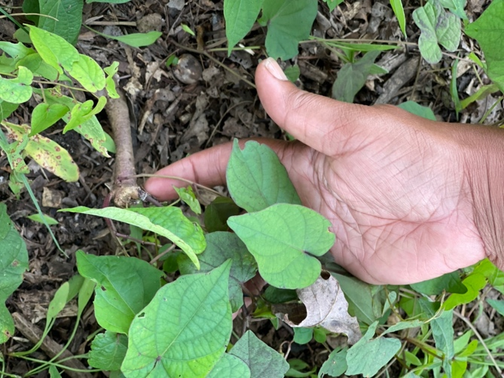
Ipomoea jalapa in Ruby’s garden, also known as High John the Conqueror, man of earth, and morning glory. Photo by Mary Hufford.
There are other legacies of slavery and of Jim Crow that account in part for the silence on BIPOC in narratives of American ginseng. “I am not rare,” reflected Ruby, “because there are other African Americans that do go in the woods and work with the plants. But there are also many that do not get down with the woods. Because if we look at the history, even in slavery, like they would be walking, and they would be allowed to go out as slaves in the woods. But if the wrong person caught you, or if you didn't have a pass, or even if you did have a pass, and they just wanted to lynch you and beat you or rape you, there's no safety there. . . So I do think it goes with the history of slavery. And then after slavery, the Jim Crow era . . . the government wasn't really stepping into to save us. And I mean, it's still an issue now.”
Through her Afrolachian Forest Farming initiative, Ruby engages a long-term restoration project that integrates African American culture and history with the Appalachian forest. Like her grandmother, Ruby is a gardener, specializing in medicinal herbs and heritage vegetables, such as whippoorwill and iron-and-clay black-eyed peas. And like Fannie Shepherd did, Ruby grows on mounds, noting that this is an African practice. Her practices of caring for the earth and its human and more-than-human communities focus on need of both forests and people for post-colonial healing. “My superpower is to show people you can make money off of regular plants that are not endangered, and still survive and still maintain the forest and keep it safe… there's so many things you can do to preserve the forest and still eat. And you don't have to sell the heart. The oldest, I call them like children, the oldest children are the forest. They have special medicines and gifts to give. But they're not to just be taken all the time.”

Ruby protects overharvested and endangered species like ginseng, black cohosh, golden seal, and false unicorn by advising landowners who want to cultivate these. As a consultant, she walks the woods of landowners to help them identify marketable non-timber forest products for which their lands are suited, and which could be propagated. “As far as the natural stands, I would not want those to be disturbed. But. . . if you want to grow ginseng, and in ten years harvest that, I’m in support of that that. In fact, I will come to your house and help you plant it!”
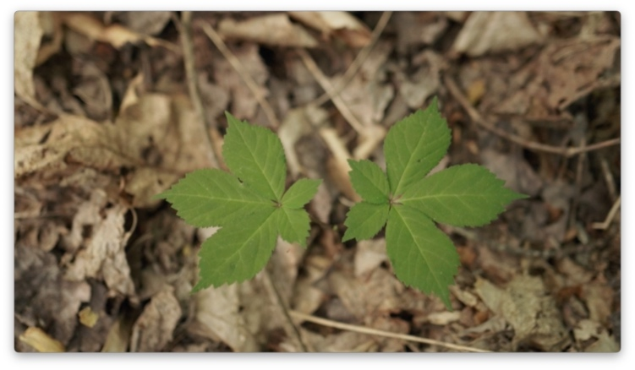
Two-prong ginseng planted by Ruby. Photo by Clara Haizlett.
Through her herbal business and workshops given around the region, Ruby educates her clients and the public about alternatives to plants that, like ginseng, have been overharvested. She often challenges the narrative of ginseng as a unique cure-all, especially for erectile dysfunction. “They have other adaptogens that help with erectile dysfunction,” said Ruby. “So I use those for people that have that issue, such as eleuthero, or Siberian ginseng.” During the pandemic Ruby fielded requests for ginseng by substituting herbs with anti-viral properties. “With COVID-19, everybody's like, ‘I need your ginseng.’ ‘No, you don't.’ For COVID-19 I use boneset it's in the woods and it's everywhere by rivers. That's better. Echinacea, the aerial part, It's easy. Like I could go clip my plant right now. Dry it and make a tea that's going to be better for COVID-19 and fight the virus better than ginseng.”
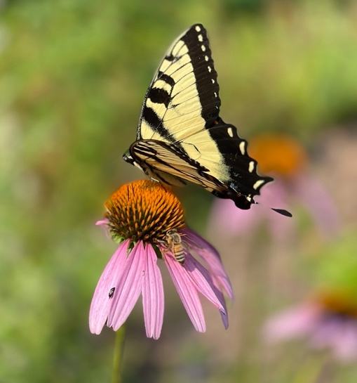
Echinacea purpurea, purple coneflower, known for its anti-viral properties, in Ruby’s pollinator garden. Photo by Mary Hufford
In the present time of post-coal, post-colonial transition, Ruby reaches into African American history to model the conservation of ginseng as an extension of the human struggle for survival. “If we can survive 500 years of enslavement. . . .It shows the perseverance that we have. And I think that's inspiring to anybody, not just black people. . . I think that fire in that survival and that perseverance is an excellent parallel for someone to make sure that ginseng survives and make sure that golden seal survives the same way we survived.”

Links to Resources:
Creasy Jane’s Herbal Remedies: https://www.creasyjane.com/
Appalachian Beginning Forest Farmer Coalition https://agroforestry.frec.vt.edu/Resources/Appalachian-Beginning-Forest-Farmer-Coalition.html
“In the Garden with Ruby Daniels,” https://www.youtube.com/watch?v=YPIevHk8t-U
“In the Kitchen with Ruby Daniels,” https://www.youtube.com/watch?v=JfZ3JyjNyYA

