Janet Hamric Hodge
Ginseng Buyer, Proprietor of Hawk Mountain Trading and WV Wildlife Resources Commissioner
Smithville, WV

Janet Hodge’s family has lived in Central West Virginia since the late l700s. Growing up in the farming communities of Gilmer and Braxton Counties, Janet learned to hunt, trap, fish, and forage for wild roots and herbs. Ginseng and other roots have historically been associated with the fur trade, and when in the early 1990s Janet began working for Dale Barker at Barker’s Fur Shed she already knew the land community as a complex web of interconnections. Along with Dale Barker, now in his nineties, Janet continues to run the business under the name of Hawk Mountain Trading. A past-president of the West Virginia Trapper’s Association who has spoken at regional and international conferences, Janet is a font of knowledge, respected by seasoned trappers and diggers, and regaled with questions from new clients about how, where, and when to sustainably harvest everything from muskrats to ginseng.

“The people that actually live here, we look at everything on the thirds: you take a third, because you have to leave some for seed, and that goes with everything. Anything that’s in the woods, when you’re digging in the woods, fishing in the river, you never take everything, because you’re biting the hand that feeds you.”

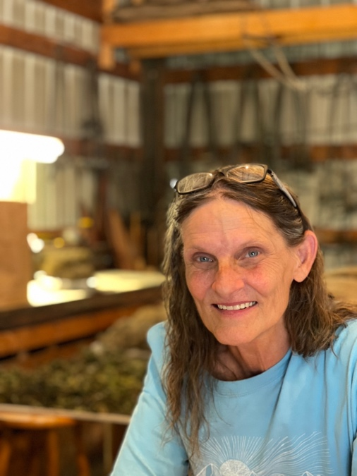
Janet Hodge, proprietor of Hawk Mountain Trading. Photo by Mary Hufford.

Janet Hodge knows the farms, fields, and forests surrounding Smithville like the back of her hand. As a girl she learned that if she wanted to buy something, she needed to earn the money for it. In the rolling hills supporting the farms and pastures of the mid-Ohio Valley are many unglaciated coves, typical of the central Appalachian forest. Too steep for farming, timbering or grazing livestock, the rich soils of the coves harbor ginseng, golden seal, mayapple, black cohosh, cranes bill, trillium and more, all of which could be redeemed for cash. When Janet was growing up, Dale Barker ran Barker’s Fur Shed, which is itself a touchstone to ginseng’s historical link with the fur trade. “Historically,” Janet recalled, “Every county had a fur buyer that was also a root buyer. They bought deer hides, beef hides, furs, roots – it was one business.”

Janet’s uncle introduced her to ginseng in the late 1960s, when she was a child accompanying him as he checked the fences. When she began digging roots, her mother created a field guide for her by ironing ginseng leaves between sheets of waxed paper. “I used those until they fell apart,” Janet said, laughing. She recalled that once she learned how to dig, she waited eagerly each spring for the price list so she could create her work plan. “I remember in my late 20s, I couldn’t wait to get my root list and study the root list. ‘What am I gonna dig? What am I gonna go after?’ And pinpoint things, because some things are early summer and some things are fall. You figure what you’re going to dig and spend a couple of hours a day at it, and you have money!”

Janet also trapped with her brother, in the early 1970s. “And the trappers association had a fur auction, including a spring rendezvous. And my brother would spend all winter getting ready to sell the furs. And my father wouldn’t let me go because he said it was no place for girls. Not a fitting place for young girls to be. And a few years later I was selling my own furs, became active in the organization and was director and organizer and just became president.”

“After I moved away from home,” Janet said, “Digging roots was a way to support my family and support my kids. And I went to the local fur buyer, which was the local root buyer, and it was Dale Barker. And within five years I was fleshing coons for him. And then I started working here – that was thirty years ago. And got my ginseng license, and my fur license, and I started from there.” Having served as the first woman president of the West Virginia Trappers association, Janet is now distinguished as the sole female commissioner of wildlife resources on the present WV Wildlife Resources Commission. For her, gender is not an obstacle. “The diggers, they don’t think there’s any difference between Dale or I, as far as is it a man’s world or a female’s.”
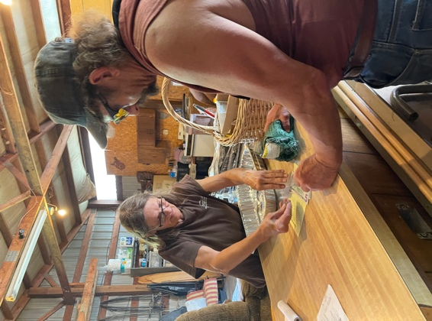
Janet Hodge completing a transaction with a client at Barker’s Fur Shed. Photo by Mary Hufford.

A conservation ethic is hard-wired into making a living from the land in Janet’s mid-Ohio Valley farming community, where woodlands that harbor ginseng and other medicinal roots have historically provided the cash needed to pay taxes and to purchase commodities like school supplies and clothes. Such woodlands were like a Trust on which community members drew with the future in mind. “If you have kids,” Janet explained, “and you’re depending on ginseng to buy your kids school clothes, you know your kids are going to be in school next year. So you don’t dig everything. You know you’re going to be coming back to dig more to buy your kids school clothes for next year.”

In mountain communities, digging roots is part of a safety net in a multiple livelihoods strategy that has been practiced for generations. “Anytime anybody’s out of work,” said Janet. “They go to the woods.” In such an economy, ginseng plays a small but vitally important part, given its high value. Janet noted that, historically, ginseng digging in the coalfields escalated during strikes, when miners and their families had to rely on income from ginseng and other roots for cash when the paychecks stopped. The unemployment crisis triggered by Covid-19 was especially hard on some of Janet’s clients. “We actually had people that were digging in the snow, because they were out of work, people that weren’t getting the unemployment plus checks. They were digging cohosh and yellow root in the snow. It was unbelievable. I’ve never seen that happen before.”

The economy supported by the woods is as diverse as the understory itself. “You’ll rarely find a guy who just traps and does nothing else. Most of the time, that guy or female, they trap, they hunt, they fish, they dig roots, probably looking for morels in the spring, they’re digging ramps – it’s just a whole huge thing. And when there’s nothing else to do, nothing in season, you walk through the woods, and ‘Oh! There’s a shed [antlers]!’ Christmas!” Ginseng is part of that mix, but rarely the sole focus. “The yellow root goes in the sack, the ginseng goes in the pocket.”

Because it is special. “Anything that’s worth something, that there’s not a lot of, is always special. It’s like a golden trout. You can see trout all day long, but when you spot that golden trout: that’s the special one! You can walk in the woods all day long, and you appreciate what’s there, but you see that ginseng: There it is! There it is!”

In addition to the state regulations, there are unwritten codes followed by root diggers and herb gatherers with whom Janet trades. Access to ginseng patches, most of them on private land, depends on the permission of the land owner, and continuing access depends on mutual trust. “Nine times out of ten, if you go up to a farmer and say, ‘You mind if I go up on the back forty and see if there’s cohosh up there?’ the farmer will say, ‘Yeah, but if you find any seng, leave it alone.’ And you do, because you want to be able to go back and dig whatever else they’re going to let you dig.”

Diggers, hunters, and trappers are crucial to the ongoing public auditing of soil, water, flora and fauna. As past-president of the West Virginia Trappers Association, and as recently appointed WV Wildlife Resources Commissioner, Janet has witnessed for decades the reliance of wildlife managers on information shared by diggers, hunters, and trappers. “I’m relying on all the people that are coming in,” said Janet during a midsummer conversation. “The people that are out there everyday, they know exactly what’s happening in the woods. They know that there’s drought conditions. Even though we’re getting rain, the river’s really low. The tops of some of the plants are dying off. “

In land-based communities, the woods have historically contributed to the development of children into self-reliant adults. Think: ginsenging as parenting strategy. When Janet’s 8 year -old grandson wanted to bring home a cat, Janet told him he could if he would dig mayapple roots to earn the money to care for it. He did, and the very portly cat sleeping next to the scale at Barker’s Fur Shed is living proof of Janet’s philosophy of childrearing, a philosophy that forms a hedge against nature deprivation in local youth. “We’re seeing less younger people,” Janet observed, recalling that when she was young “a lot of people dug roots, they trapped, they hunted. And now they watch videos and play games about hunting or trapping.” Asked what kids are missing out on, Janet exclaimed: “They’re missing out on real life! My grandson, if he sits down with his phone and he’s doing video chatting, or watching video games, he wants to continue to sit, to lay back in his chair and ‘Get me something to drink!’ The longer he sets, the worse he gets.”

The antidote? Time in the woods. “My daughter will come in and say, ‘Hey, let’s go fishing!’ And he’s up and he’s out and they can fish for two days and he never once remembers his phone. And kids have got to have that!”

At one time Barker’s Fur Shed bought and sold ginseng seeds and tops, as well as wet roots. Now Janet only buys and sells dried ginseng roots. Customers come and go, bearing sacks and tubs of wildcrafted yellow root, snake root, cohosh, and ginseng.

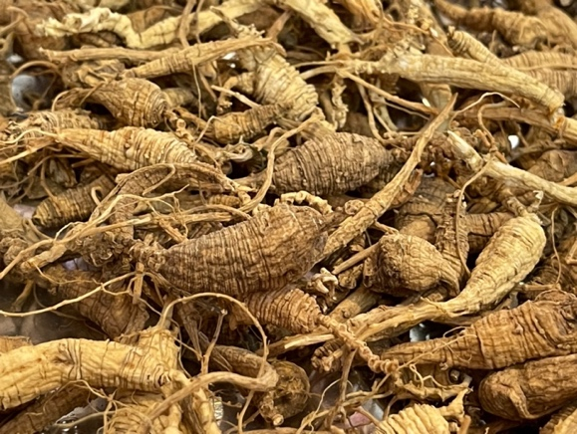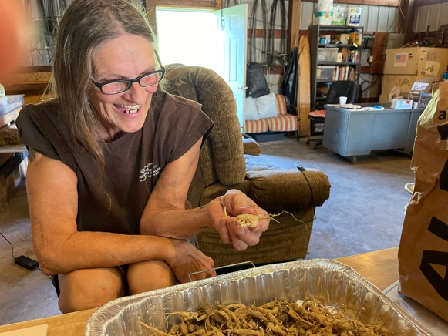
Each ginseng root bears traces of its history: what part of the region it came from (i.e. boney = coalfields; bulby = mid-0hio Valley), whether it was wild or transplanted, and tell-tale signs of defective wildcrafting. “Like the person who brought this in. I had to remind them not to use a toothbrush to clean their ginseng. They got this crazy look on their face, like, ‘How did you know?’ It sticks out, doesn’t it! You want it clean, but not too clean.” Photos by Mary Hufford

Some seek advice on how to craft their roots. A young woman named Chandra walks in with her young son and a bag full of yellow root and blood root. “What can I do to keep my blood root from molding on me?” Chandra asks. Janet counsels her to arrange it loosely and to keep a fan running, adding “The blood root and the black cohosh are the two easiest things to mold. Your blood root looks real good. You did a great job with it.” Chandra wants to know the difference between Solomon’s seal (Polygonatum sp.) and false Solomon’s seal (Maianthemum racemosum). On the back of a receipt, Janet pencils an illustration of the contrast between the delicate green bell-shaped blooms dangling from the leaf axils of Solomon’s seal, which turn into dark blue berries, and the creamy white plume of clustered flowers at the end of the stalk of false Solomon’s seal, which give way to ruby red berries.
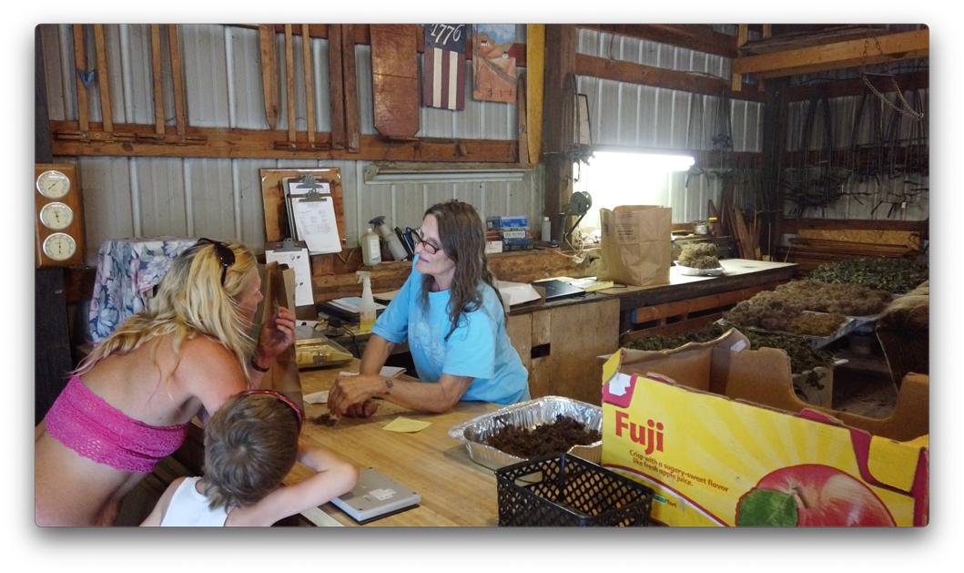
Chandra, learning from Janet Hodge to identify Virginia snakeroot by the smell. Photo by Daisy Ahlstone.

Janet wants to know whether Chandra’s son helped dig these roots. It turns out that his mayapple is still at home, drying. “I’m really proud of you digging mayapple!” Janet tells him. “Make sure you bring yours in. Get a good price for your mayapple!” Like most root dealers in the region, Janet pays young diggers more for their roots, as an incentive for them to spend more time in the woods.

“You know what I noticed?” Chandra says, “If you see mayapple, chances are you’re going to find every root in the area.”

“Everything that’s good kinda grows in the same area,” Janet agrees. “In that dark woods.”

Chandra muses, “I don’t like going there and just digging it all up. I’ll dig here and there and yonder. I don’t like digging it all in one place. If people go there and just dig it all up, there won’t be none.” There is joy to be had in the hunt itself. “I really enjoy doing it. I like digging it. I like finding it. It’s like a game. They hide – like morel mushrooms -- they hide in their surroundings and you find them.”

Chandra turns to her son. “Guess what! Let’s dig some more roots.” Then to Janet: “He’s got his own little digger and everything. We’ll be back in a couple of weeks!”

Links and Resources:
Noonan, Bob. “A Lady Living Off the Land: Smithville’s Janet Hodge.”
https://www.hurherald.com/cgi-bin/db_scripts/articles?Action=user_view&db=hurheral_articles&id=20187
WV Trappers Association. http://www.wvtrappers.com/
McCoy, John. WV DNR Director Seeks Input on Ways to Improve Hunting, Fishing. Charleston Gazette-Mail. Nov. 21, 2017
https://www.wvgazettemail.com/outdoors/wv-dnr-director-seeks-input-on-ways-to-improve-hunting-fishing/article_c7c2b8e9-dacb-5541-a7fb-6f3373e87040.html

