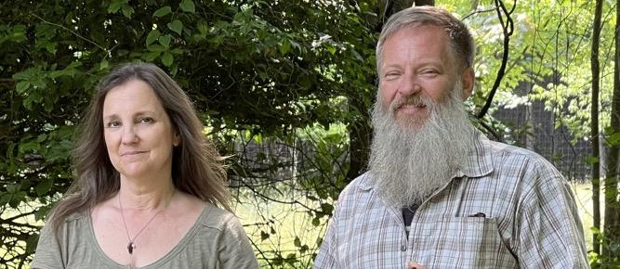

**Ed and Carole Daniels**

[**Shady Grove Botanicals**](https://www.shadygrovebotanicals.com/)

**Mill Creek, WV**

Carole and Ed Daniels, Shady Grove Botanicals, Mill Creek, WV. Photo by Mary Hufford

**Background and Training**

Ed Daniels, 53, grew up in Mill Creek, West Virginia. His great grandfather, Charles Daniels, the first Daniels to settle in the region, was a self-taught healer who doctored in the logging camps of Randolph County around the turn of the nineteenth century. Ginseng and goldenseal featured prominently in his practice, and Ed attributes his own interest in medicinal understory plants to time spent as a boy in the woods with Dr. Daniels and others in the lumbering community who shared with him their knowledge of the woods. With his wife, Carole, Ed is developing his forest farm at their property on Hicks Ridge in Pickens, (home of the oldest and largest maple syrup festival in West Virginia). In what Ed calls “a mix of both worlds,” Ed and Carole combine livelihood strategies: growing produce at their farm in Mill Creek, and cultivating understory medicinals (including goldenseal, ginseng, and black cohosh) in their woodlands upstream on Hicks Ridge. During the school year, Ed drives a school bus. In the absence of any blueprint registering the diversity of sites and habitats in Central Appalachia, Ed takes what he calls a “slow” approach to forest farming, grounded in “continual experimentation.” For example, planting things too close, and also sparsely, he learns to make adjustments based on differences in results. “Each farmer,” he said, “has to get to know their own land. We’re constantly changing some things just to either get better or see how far we tweaked it the wrong way!”

**Cultural Values and Meaning**

Making a living by working with the Central Appalachian forest where his ancestors lived and worked, and where Ed and Carole have raised their children is important to Ed, who hunted on the Hicks Ridge property as a teenager. He had always hoped to own the property and was eventually able to buy ten acres, expanding his operation by leasing an additional 3,000 acres. On this land Ed and Carole practice traditional food foraging (for ramps, mushrooms, and wild berries) while developing innovative techniques for cultivating and processing medicinal understory plants. A threshold to the past and to the future, the land on Hicks Ridge connects Ed and Carole to their ancestors, and to their descendants. Actively marking that connection, Ed and Carole have set aside a particular site for medicinal herbs, named ‘Briar’s Patch,” as a legacy for their grandson, Briar.

A key value is the capacity to live from the land and to care for it in ways that are physically and spiritually nurturing, and socially and economically sustaining. Ed and Carole actively foster that capacity in Randolph County schools through their “Plant the Seed” program, which has placed high tunnels at three schools where students are learning to cultivate food and medicine, and to steward woodlands and sustain their potential to support human and economic development. The contributions of Ed and Carole Daniels to the cultural value of agroforestry has in recent years been recognized by state and federal cultural agencies.

In 2020, the WV Folklife Program (in the state’s Division of Humanities) awarded an apprenticeship grant to Clara Haizlett of Brooke County, who wanted to study forest farming with Ed Daniels. The grant paid for Clara’s travel and for Ed’s time in teaching her. which included canning deer meat, mushroom hunting, and sowing seeds for ginseng, goldenseal, and hemp. She in turn has instituted a childrens’ summer camp in Brooke County, with a forest farming stewardship day. In 2022, Ed and Carole Daniels presented on ginseng for a program called “American Ginseng: Local Knowledge, Global Roots,” at the Smithsonian’s Festival of American Folklife, in Washington, D.C. 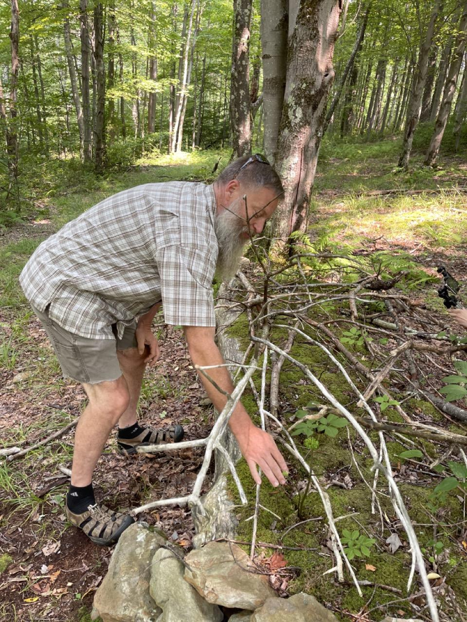

Ed Daniels, “brushing” his ginseng patch. Photo by Mary Hufford

**Ecological Dynamics of the Site**

The acreage leased by Shady Grove Botanicals provides a variety of spaces needed to cultivate understory medicinals. With north, east, south, and west facing slopes, Ed and Carole are able to grow small patches of cohosh, ginseng, and goldenseal and other understory plants that rely on mixed mesophytic (medium moisture loving) conditions. The topography of the mixed mesophytic slopes ensures proper drainage, air flow, balance of light and shade, and associations with hardwood species that enhance the growth of medicinal understory plants. Sugar maples, for example, supplement soil with calcium that benefits species grown by Ed and Carole. While inhibiting plantation-style agricultural production, the cove and valley topography is perfectly suited to the production of understory medicinals, enhancing drainage, airflow, and the interplay of light and shade needed to grow the remarkably distinctive understory gifts of the Appalachian forest.

Confined by topography and microclimates to small, level patches of rich soil distributed throughout the property, agroforestry in Central Appalachia promotes targeted forms of pest control. “Deer browse,” for example, may be controlled through the application of cayenne pepper sprays, fencing, and the practice of “brushing” – sheltering sprouting seeds of medicinal plants beneath a lattice of brush. Brushing also contributes nutrients to the soil as the brush is broken down over time by shredders. Dispersed cultivation in small patches also defends against the spread of disease that so often plagues monoculture planting, which can be catastrophic. Cooperating with the free labor the terrain has given, Ed is able to avoid the use of herbicides. “I don’t think you’ll find Roundup here,” he commented.

**Land Tenure and History of the Site**

Like much of West Virginia’s forested land, Hicks Ridge was historically cleared for farming. Ed reads that history of the land from what is there now. Rock piles indicate spaces that were cleared for growing crops. A mature stand of pine trees marks a former Christmas tree farm. Horseshoes turned up in the soil indicate horses kept by previous owners, and, Ed conjectures, likely had sheep, a cow, and a subsistence garden. In recent decades, as with most woodlands in West Virginia, the understory on Ed’s land has been heavily impacted by browsing deer. While in need of eco-restoration, the land retains its historical capacity to support medicinal plants. Ed and Carole discover and harness that capacity through constant observation and experimentation. Ed has observed, for example, that “cropping” ginseng in the treetops left on the ground in timbered areas can shelter ginseng from browsing deer, and possibly from ginseng thieves. Experimentation allows him to replicate intentionally what historically came about through serendipity. Working with historical legacies to restore habitat for shade-grown medicinals, Ed pointed out, is a way of “building a better ecosystem right here.”

.

**Values of the landscape: Forest Farming Management and Production**

Shady Grove Botanicals exemplifies a growing effort to keep raw non-timber forest products in the region for processing, expanding opportunities for ecologically sustainable livelihoods. Ed and Carole produce a variety of products, including salves, tinctures, teas, and seeds and root propagules for agroforesters starting patches ginseng, goldenseal, cohosh, and bloodroot throughout Central Appalachia. Value is added by expanding the range of products afforded by each species, which also contributes to the sustainability of medicinal botanicals. For example, stewarding ginseng for the medicinal values of the leaves and berries allows the roots to remain in the ground and to mature.

“The berry juice,” said Ed, “will give you energy like you’ve never experienced before, it’s really good, clean, far beyond caffeine. . .There’s a lot of uses of the plant above the ground and the root would still stay there. Very sustainable.” Maintaining the value of roots that he transplants, Ed has perfected a technique that preserves the wild appearance of the root. The wilder the root, the higher its value in global markets. Ed’s technique entails carefully transplanting each root using a dibble bar. “It is research and development all the time,” said Ed.

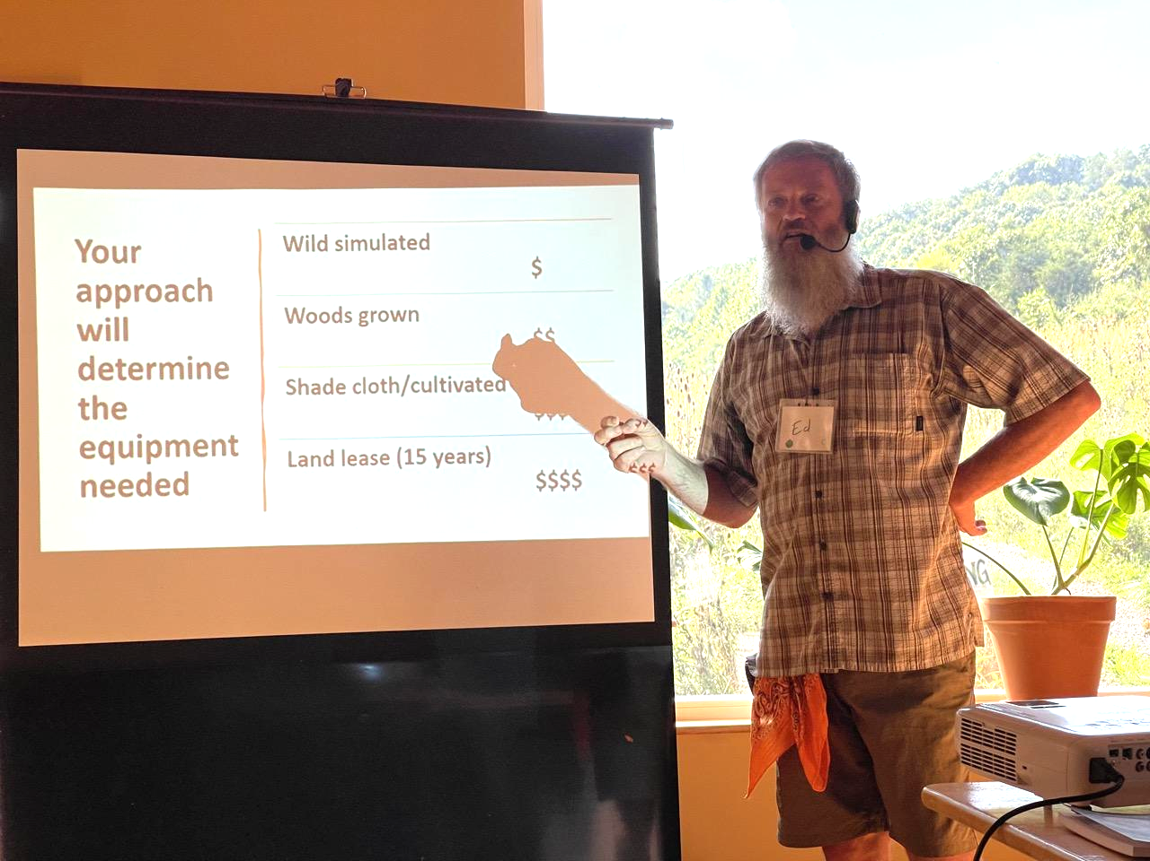

Ed Daniels presenting at an Appalachian Forest Farming Conference at United Plant Savers, Rutland, Ohio, in 2021. Photo by Mary Hufford.

**Values of the Activities: Labor and Livelihood**

One of the most frequently cited benefits of agroforestry is the opportunity to make a living from woods that are at the same time an object of care. Like other forest farms, Shady Grove Botanicals manifests the ideal of livelihoods as inseparable from the ongoing cultivation of relationships to nature and community. Ed enters the woodland ecosystem as a co-worker, turning steep slopes, shade, drainage patterns, and microclimates into assets. He frequently expresses a love of being in the woods, which is in a sense reciprocated. “That’s love right there,” Ed marveled, recounting his discovery of ginseng maturing underneath tree tops left years earlier by timber workers. Spending time in the woods, highly prized among root diggers and herb gatherers from whom Ed and Carole buy some of the raw materials for their products. Communal bonds formed around shared love of woodlands are renewed and celebrated through festive events. Ed and Carole hold an annual festival on Hicks Ridge, at which friends gather to listen to music, camp out, and celebrate forest bounty consumed together on these occasions. The shared relationship to natural species that uniquely occur within a region becomes a powerful means of social bonding, celebrating those bonds, and supporting the labor that brings forth food and medicine. Teaching children, through their Plant the Seed program, to recognize plants and to gather and dig seeds, nuts, and roots, Ed and Carole initiate new generations into the joys and benefits of working in and with the woods. 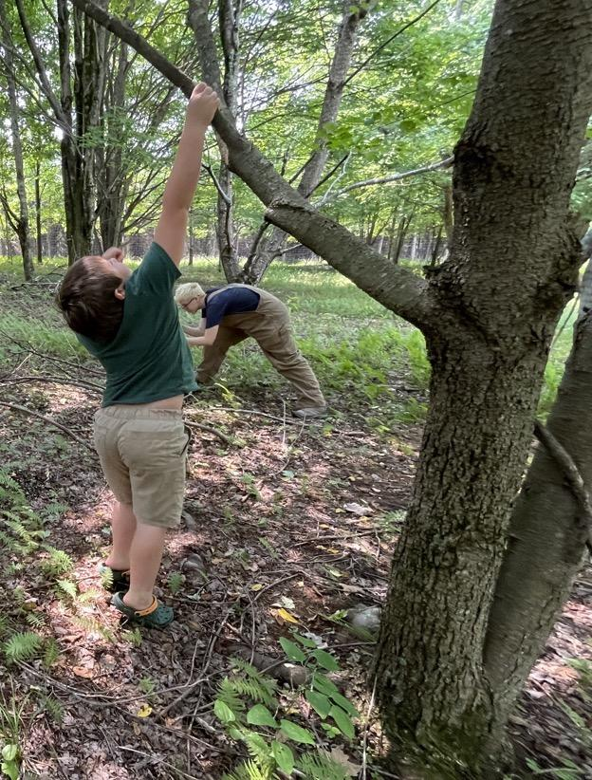

Ed and Carol’s grandson, playing in the woods of Shady Grove Botanicals. Photo by Mary Hufford.

**Values outside the landscape/site: Economics and Marketing**

In addition to selling products through their website, Ed and Carole are educators. Participating in networks that support forest farmers, such as the Appalachian Beginning Forest Farmers Coalition, they travel throughout the Central Appalachian region to share knowledge and provide resources for those wishing to begin forest farming. Teaching what they’ve learned also generates income. Ed and Carole are often invited to present at forest farming field days, meetings of herbal associations, wild food festivals, and, recently, at the Smithsonian Festival of American Folklife. In 2020, Ed was awarded an apprenticeship grant by the West Virginia Folklife Program, to teach Clara Haizlett how to develop her forest farm in Brooke County. Festivals, farmers markets, conferences, and speaking engagements offer opportunities to sell botanicals and products, and are crucial for knowledge sharing about forest farming. Through such opportunities, Ed and Carole have become leaders in Central Appalachia’s expanding forest farming movement. Finally, festive occasions provide time-out for reflecting on and celebrating the forests that hold people together in community. Creativity abounds, from musical compositions celebrating non-timber forest products (“Shaking Down the Acorns,” “Ginseng Sullivan”) to innovative recipes, like the snake meat used to produce Appalachian crab cakes, served up as “snake bites”! 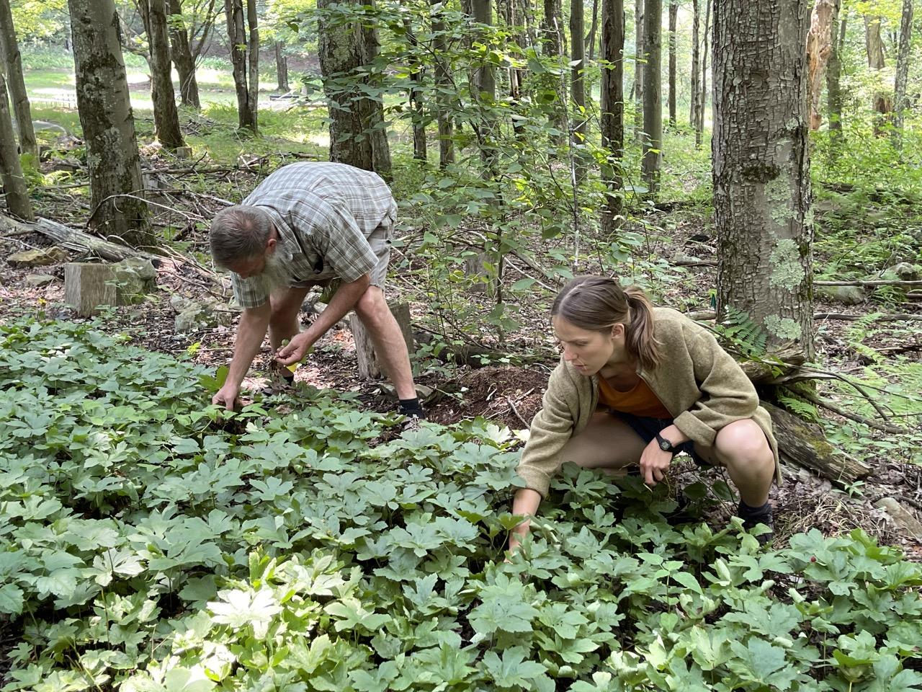

Ed Daniels, harvesting goldenseal with Clara Haizlett on West Virginia’s first forest farming apprenticeship, supported by a grant from the Folklife Program of the WV Humanities Division.They used this goldenseal to make a fungicide to treat tomatoes on Ed and Carole’s high tunnel. Photo by Mary Hufford.

**Future Plans**

Ed and Carole are continually thinking about the potential uses for untapped resources, such as tree saps (including maple sap and pine resin) and nuts, sometimes drawing on the past for inspiration. “Fresh cracked hickory nuts and peanut butter,” said Ed, “is the bomb. My grandmother always did that. I was the one that got her the hickory nuts.” With an eye on the future, Ed and Carole are cultivating a generation of children, instilling in them a capacity for stewarding non-timber forest products. This vital task of agroforestry requires the support of public policy. Ed envisions, for example, a state seed bank that would supply those foraging with permits on state and federal lands with seeds to replenish the ginseng they harvest. “That’s our focus, you know: always put something back.”

– Written by Mary Hufford